Nomination of a Co-correspondent
From ꢀme to ꢀme the Local Authority will contact you by leꢁer or email. To ensure you are
supported in responding and carrying out any acꢀon required you can nominate a co-
correspondent.Your nominated co-correspondent will be noꢀﬁed by the Local Authority when
a leꢁer or e-mail is sent to you.
Applicant/Tenant Details
Name of Applicant/Tenant:
Applicant/Tenant Date of Birth:
___ ___ / ___ ___ / ___ ___ ___ __
Housing Applicaꢀon Number
Applicant/Tenant PPS Number
(If applicable):
Applicant/Tenant Consent
Please indicate your consent by ꢀcking the box below
I give consent to the Local Authority to noꢀfy my nominated co-correspondent
when correspondenceis issued to me.
Your rights as a data subject under the General Data Protecꢀon Regulaꢀon (GDPR) apply in
full and are clearly set out in the Local Authority’s Privacy Statement. Copies of this are
available are at the Local Authority’soﬃces. If you have any questions about your rights under
GDPR, you can contact the Local Authority’s Data Protection Officer, or you may contact the
Office of the Data Protection Commissioner(ODPC).
You must noꢀfy the Local Authority in wriꢀng if you wish to withdraw this consent at any
date in the future.
Applicant/Tenant signature:
Date:
___ ___ / ___ ___ / ___ ___ ___ __
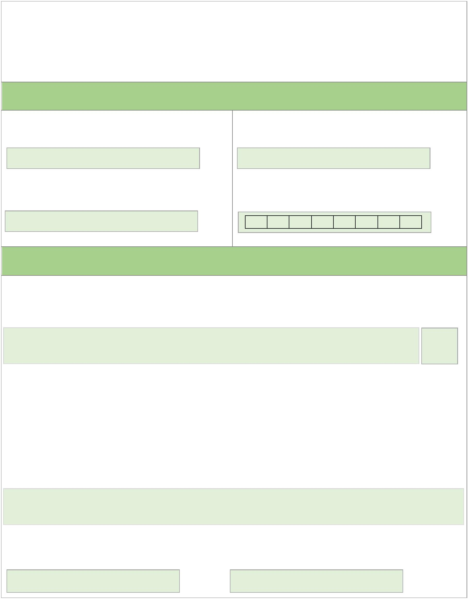

Nomination of a Co-correspondent
Co-correspondent Details
Co-correspondent Name:
Co-correspondent Tel:
Co-correspondent Address:
______________________________________
______________________________________
______________________________________
Co-correspondent Consent
Please indicate your consent by ꢀcking the relevant boxes below
I give permission for the data I have provided to be stored by the Local Authority
I consent to receiving noꢀﬁcaꢀon of any communicaꢀons issued to applicant
overleaf in relaꢀon to their Social Housing Support Applicaꢀon or tenancy
Your rights as a data subject under the General Data Protecꢀon Regulaꢀon (GDPR) apply in
full and are clearly set out in the Local Authority’s Privacy Statement. Copies of this are
available are at the Local Authority’soﬃces. If you have any questions about your rights under
GDPR, you can contact the Local Authority’s Data Protection Officer, or you may contact the
Office of the Data Protection Commissioner(ODPC).
You must noꢀfy the Local Authority in wriꢀng if you wish to withdraw this consent at any
date in the future.
Co-Correspondent Signature:
Date:
___ ___ / ___ ___ / ___ ___ ___ __

