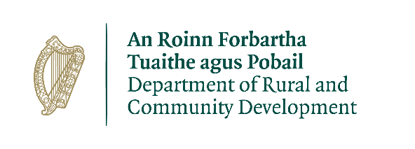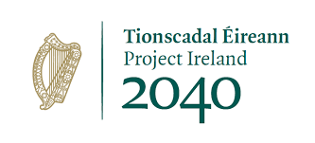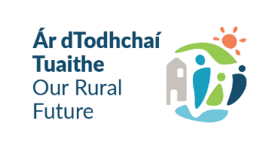
CLÁR Funding 2022
Project Application for Measure 1:
Developing Community facilities and amenities

Project Name:
Short Project Description: (Less than 20 words – will be published on approved list if project is approved)
Project implementation directly by the Local Development Company (LDC) (Yes/No)
Please provide contacts details, if applicable:

Community Group/School/LDC Information
Group Name:
Contact Person and Position Held:
Address:

Email:
Telephone No.:

Project Information
Facility Name:
Please provide the Eircode or XY (ITM format) Co-ordinates of the project:
Xy coordinates should be captured in Irish Tranverse Mercator (ITM) formats. Coordinates can be converted to ITM format here: https://gnss.osi.ie/new-converter/. This data will be used to geo-map all successful projects.
DED NAME and ID:
Confirm that the project is located in a CLÁR area Y/N:
Location of proposed works, if different from above:
Are these works part of a larger project Y/N:
If Yes, please provide details.
Does the applicant own the property or is there a minimum 5 year lease in place:
Please provide details
Outline the nature and scope of the works:

Outline of the need and rationale for the works:

Outline if the project includes an enhancement of biodiversity e.g. native pollinator plants:

Has an application in respect of this facility been pproved under CLÁR or any other scheme in the past 3 years (Y/N)?
If yes, please provide details.
Has an application for funding for this project been submitted to any other scheme or programme (Y/N)?
If yes, please provide details.

Detailed Costings for Proposed Project:
Please provide detailed breakdown of all elements of the proposed works including any administration/other fees/costs:
Project Elements  (provide details of each element ) | Cost (inc. VAT)
 | €
 | €
 | €
 | €
 | €
Local Authority Costs (if applicable)
 | €
 | €
Professional fees:  (e.g. architectural, engineering, survey costs) max 10% | € | % of overall project  %
Total Cost | €
Funding amount sought:  (Maximum 90% of total cost up to €50,000) | €
Match Funding:  (Minimum 10% of total cost) | €
Source(s) of Match Funding: (LA/LDC/school/community/philanthropic body)

Use of Data
The information on this Application Form will be used by the Department of Rural and Community Development for the purposes of processing the application. Further information may be sought by the Department to clarify aspects of the project proposal.
The Applicant and the Department are subject to the data protection and privacy laws of Ireland and the EU, in particular the Data Protection Act 2018 and Regulation (EU) 2016/679, known as the EU General Data Protection Regulation (“GDPR”).
The Department retains the right to disclose for the purposes of a request under the Freedom of Information Act 2014 or otherwise, in connection with the funded project(s) –
i. any information supplied by the Applicant to the Department,
ii. any relevant data gathered by the Department in administering grant aid to the project, except where the information is considered to be personal or commercially sensitive.

Applicant Declaration
I confirm that the particulars of this application are correct and that
- The project is based in a CLÁR area
- Match funding is available and ringfenced for the project
- All necessary permissions are in place (evidence of any planning permissions and other other consents must be submitted with your application.
- Evidence of ownership/minimum 5 year lease is available (if applicable) – (written evidence must be submitted).
- The facility is/will be open to the public without appointment
- The necessary insurance is in place (please submit copy of same)
- Projects that allow the lighting of fires e.g. BBQs have the express permission of the landowner on file
- The project conforms to the LECP and/or other local or regional plans
Name: _____________________________________________________________________

Signature:__________________________________________________________________

Role in Group / Organisation: _________________________________________________

Please return completed application form to:
Administrative Officer
Rural & Community Development
Rural Directorate
Áras Contae an Chláir
New Road
Ennis
Co Clare
or email to mailto:clar@clarecoco.ie
The closing date for receipt of applications is Thursday 31 March at 4pm.

CLOSING DATE & TIME WILL BE STRICTLY ADHERED TO

Queries can be directed to mailto:clar@clarecoco.ie

