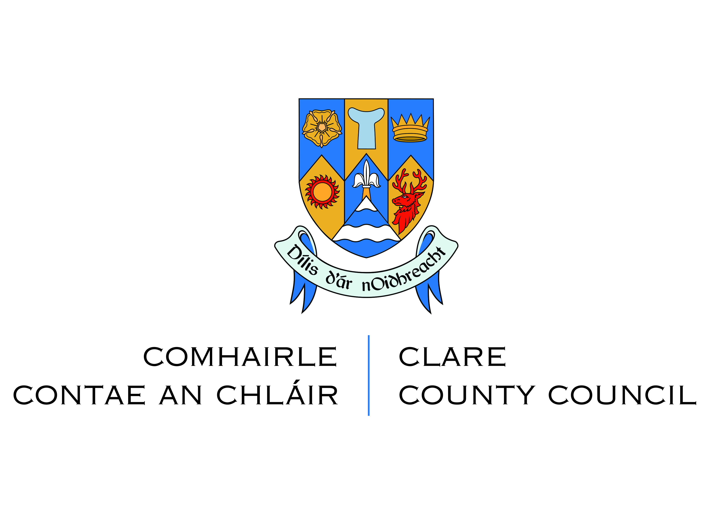
Guidance for completing Derelict Sites Complaint Form
PLEASE READ CAREFULLY BEFORE COMPLETING THE FORM

1. Clare County Council’s Role
Clare County Council is responsible for dealing with Derelict Sites in County Clare. It is an objective to investigate reports of dereliction and take action in accordance with the Derelict Sites Act 1990, as amended.

Before making a complaint, please read these guidelines carefully and contact us (details below) if you have any questions.

2. When should I fill out this Complaint Form?
You should fill out this form if you are concerned about a derelict site in your area. Under the Derelict Sites Act 1990, as amended, a ‘derelict site’ means any land which detracts, or is likely to detract, to a material degree, from the amenity, character or appearance of land in the neighbourhood of the land in question because of the following:
- The existence on the land in question of structures which are in a ruinous, derelict or dangerous condition; or,
- The neglected, unsightly or objectionable condition of the land or any structures on the land in question; or,
- The presence, deposit or collection on the land in question, of any litter, rubbish, debris or waste, except where the presence, deposit or collection of such litter, rubbish, debris or waste results from the exercise of a right conferred by or under statute or by common law.

3. Issues the Derelict Sites Team does not deal with?
The Derelict Sites Team does not investigate civil matters, for example:
- Land or Ownership disputes
- Trespass
- Private nuisance (noise, vandalism) etc.

For other matters such as those relating to the environment, roads, water, drainage, housing, litter and illegal dumping etc. you should contact the relevant Department of Clare County Council.

4. I am satisfied that my complaint is about a derelict site. What do I need to do?

It is important that you provide as much information as possible to help us carry out a proper investigation. The following should be provided:
- The address or location of the derelict site including Eircode if known.
- A map showing the location of the derelict site. This will help us to locate and investigate the correct site. Clare County Council’s online Planning Enquiry System or Google maps can provide a suitable map.
- Photographs of the derelict site would also be helpful for identification purposes.
- The names and addresses (including Eircodes) of all owners and occupiers of the site, if known. This will help us to act more quickly in dealing with a derelict site.
- An accurate description of the derelict site including the reasons why you consider it to be derelict.
- A fully completed, signed and dated Complaint Form, with the name and address (including eircode) of the person making the complaint.

5. What happens after I fill in the form and give it to you?
We will do the following:-
- Send a letter to you to acknowledge the complaint has been received;
- If we need further information from you, we will write to you to request this information;
- Inspect the site and prepare a report with recommendations as to the next steps:
  - If we do not consider the site to be a derelict site, we will close the file and notify you of our decision.
  - If we decide that the site is in fact a derelict site, we will take required actions under the legislation and may put it on the Derelict Sites Register. We will also write to you to inform you of this decision.
- Further action will depend on the owner and occupier’s response and actions.

6. Will we contact you after you have lodged the complaint?
Yes. We will acknowledge your complaint and you will be kept informed through all stages of the process. If you become aware of new information regarding the site, you should write to us immediately.

IF YOU HAVE ANY QUESTIONS, PLEASE CONTACT:

Derelict Sites Team
Economic Development Department
Clare County Council
Áras Contae an Chláir
Ennis, County Clare V95 DXP2

Tel: (065) 684 6452
Email: derelictsites@clarecoco.ie

Derelict Sites Complaint Form

Location of Derelict Site (Please give as much detail as possible and attach a Site Location Map - complaints that are not accompanied by a site location map may not be followed up)

Names and Addresses of all Owners and Occupiers, if known (include Eircodes)

Reason for Complaint (An extra sheet may be used to provide additional information if necessary)

Name and Address of Person making complaint (include Eircode)

Contact Details of Person making complaint (including telephone number and email address)

I HAVE READ THE GUIDANCE RELATING TO THIS FORM
Signature: Signed: _______________________________________
BLOCK CAPITALS: _______________________________________
Date: _______________________________________
NOTE: Complaints may not be investigated unless a fully completed, signed and dated Complaint Form is provided, with the name and address (including Eircode) of the person making the complaint.

Please return completed forms to:

Derelict Sites Team
Economic Development Department
Clare County Council
Áras Contae an Chláir
Ennis, County Clare V95 DXP2
Email: derelictsites@clarecoco.ie

IMPORTANT DATA PROTECTION INFORMATION: PLEASE READ
The Council has a Privacy Statement which is a general document about how we approach data protection as an organisation. This is available on request from the Economic Development Directorate (065) 684 6452 or on the Council’s website (https://www.clarecoco.ie/[info]/privacy-statement/). Information is also provided in relation to Derelict Sites in the enclosed Privacy Notice which you are advised to read. This is also available on request from Economic Development Directorate or on the Council’s website (https://www.clarecoco.ie/services/economic-development/derelict-sites/). Data you supply will be recorded on an MS Word document, and a hard copy file and related documentation which are held in secure storage. Access to the data is controlled and restricted to relevant staff of Clare County Council involved in Derelict Sites, with security measures such as passwords. All correspondence in relation to Derelict Sites, including your personal data, will be held and disposed of in compliance with the National Retention Policy for Local Authority Records which can be accessed at the following link: https://www.lgma.ie/en/publications/corporate/national-retention-policy-for-local-authority.pdf
If any of your personal details change, please advise the Derelict Sites Team on derelictsites@clarecoco.ie or telephone (065) 684 6452.
CONSENT
Do you consent to the information on this form supplied by you, to be held on file by Clare County Council for the purpose of regulation of Derelict Sites under the Derelict Sites Act 1990, as amended: Yes No

Please tick your preferred method to be contacted (√): Yes No
Do you give consent to Clare County Council to be contacted by Post
Yes No
Do you give consent to Clare County Council to be contacted by Email
Yes No
Do you give consent to Clare County Council to be contacted by Phone

You can withdraw your consent at any time by telephoning (065) 6846476 or emailing: derelictsites@clarecoco.ie
Please see privacy statement https://www.clarecoco.ie/[info]/privacy-statement/

ADDITIONAL INFORMATION

